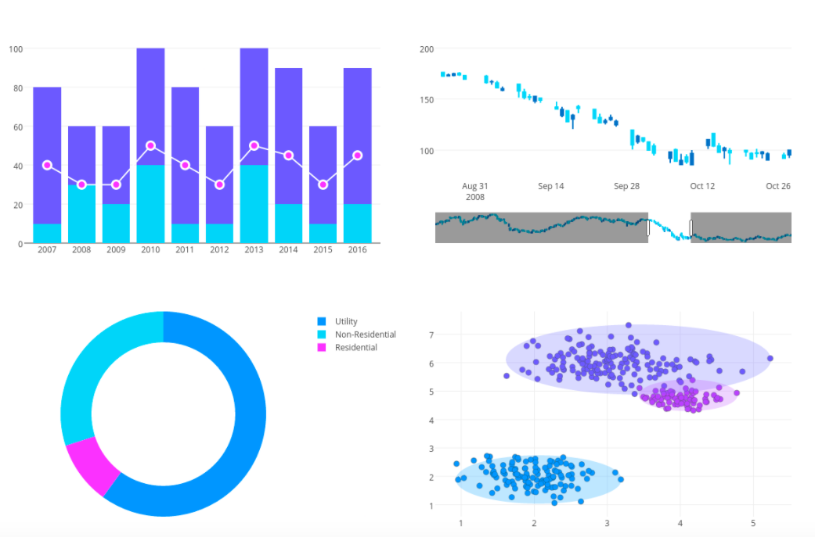

|  |
| --- |
| **Data Visualization**  **Aim: How can visualizing data be useful?**  **Objective: With scaffolds, students will be able to visually present information from source data programmatically**  *References:*   * *Plotly graph documentation:* [*https://plotly.com/python/*](https://plotly.com/python/) * *Pandas Data Types:* [*https://pbpython.com/pandas_dtypes.html*](https://pbpython.com/pandas_dtypes.html) |

**Lesson Overview:**

1. Students examine excel document of data
2. Students program in python to manipulate data (jupyter notebook + pandas)
3. Students program in python to graph data (jupyter notebook + plotly)

**Themes:**

* What are the benefits and limitations of text data? (excel)

* What is a library? (pandas and plotly)

* Jupyter notebook (maybe we can assume they are already familiar with this)

* pandas

→ data frame

* plotly

→ graph objects (<https://plotly.com/python/bar-charts/>)

→ figures

→ graph types (bar, pie, line, etc)

**Student Task:**

Students will start with a pre-made excel file and a template graphing code. They will complete missing code elements in order to visually present data. Students will create several different plots described in problem prompts and will create their own plot from an open ended prompt as an exit ticket.

**Extension:**

Sliders, dropdown menus, and interactive elements

**Required Resources:**

Jupyter Notebook: <https://jupyter.org/install>

Python Plotly **and Jupyter Notebook extension**: <https://plotly.com/python/getting-started/>

Class: Intro CS / 9th grade Teacher: Date: September 2020

Unit: Data

Aim: What are the benefits and limitations of text data (excel)?

Objective: SWBAT understand and articulate the benefits and costs of text data.

SWBAT understand the limitations of text data.

SWBAT articulate an example when text and/or visual representations of data would be more

useful.

Standards:

NYS K-12 Computer Science and Digital Fluency Standards, Computational Thinking, DATA ANALYSIS AND VISUALIZATION

9-12 CT-3. Refine and visualize a large data set using an appropriate tool in order to persuade an audience.

**Materials**

|  |  |
| --- | --- |
| Do Now: 5 minutes | Prompt for Stop & Jot / Turn & Talk:  What is data? [Expected response: information, numbers, facts, statistic]  How/where do we store data? [Expected response: charts, graphs, tables, lists ,etc] |
| Mini Lesson: 7 minutes | Why would we want to use data?   * To tell a story * To give information * To persuade * To analyze   When would we want to use different types of data visualizations?  [Depending on our goal - certain might be more easy to read quickly on a commercial]  Is there any way we can categorize these? Text vs visual  [Put text / visual categories on board, have students categorize them]  Navigating data in Excel: How can we do we want to be able to |
| Activity: 20 minutes | Explore data set:  What were the number one songs in 2019? [text-appropriate]  What song was number one the longest? How do you know? [text-appropriate]  What genres of songs were most popular in the top 20? [text-appropriate]  What percentages of songs in the top 20 belong to each genre? [visual]  What is the total percent of top ten artists that are: solo artists? Collaborations? [visual] |
| Closing/Exit Ticket: 5 minutes | What benefits can you see about using spreadsheets?  What are the limitations? |
| Homework: | Consider what you might want to convey that would not lend itself well to spreadsheets? |

Materials:

Likely questions:

**Day 2 Student Materials**: https://docs.google.com/document/d/1XTRFMspGJxOjsxnrQinWsA_ILWIzCvlejn7uuKgJ8aY/edit?usp=sharing

|  |  |
| --- | --- |
| Do Now: __ minutes | Try to describe the the types of information you will find in each column of our 2019 Billboard data set using only one word (Text, String, Integer, Number, Boolean, Float, Date, etc)    Table partners Turn and Talk to compare category descriptions. Stop and discuss reasonings for categories that you described differently |
| Mini Lesson: __ minutes |  |
| Activity: __ minutes | **Data Manipulation** |
| Closing/Exit Ticket: __ minutes | Exit ticket previews Day 3 lesson by prompting students to make hypothesis about function of graphing code |
| Homework: | N/A |

**Day 3 Student Materials**:

https://docs.google.com/document/d/1woHvlcwWMFa_uuRYD2khZ81Lz8kzijbVBse62GPmvTM/edit?usp=sharing

|  |  |
| --- | --- |
| Do Now: __ minutes |  |
| Mini Lesson: __ minutes |  |
| Activity: __ minutes |  |
| Closing/Exit Ticket: __ minutes |  |
| Homework: |  |